Dokumentasi Praktikum PBO 9

Mata Kuliah : PBO - TI - S1

Pertemuan : 9

NIM : A11.2021.13254

Nama : Yohanes Dimas Pratama

**Contoh Program Exception**

Hasil Program:

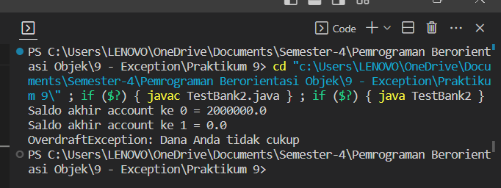

Code Program:

*Account.java

public class Account {

    protected double balance;

    protected Account(double initBalance) {

        balance = initBalance;

    }

    public double getBalance() {

        return balance;

    }

    public void deposit(double amt) {

        balance = balance + amt;

    }

    public void withdraw(double amt) throws OverdraftException {

        if (amt <= balance) {

            balance = balance - amt;

        }

        else {

            throw new OverdraftException("Dana Anda tidak cukup", amt-balance);

        }

    }

}

*TestBank2.java

public class TestBank2 {

    public static void main(String[] args) {

        int i;

        Account[] accounts = new Account[100];

        accounts[0] = new Account(2000000);

        accounts[1] = new Account(0);

        for (i = 0; i < 2; i++) {

            double b = accounts[i].getBalance();

            System.out.println("Saldo akhir account ke " + i + " = " + b);

            try {

                accounts[i].withdraw(1000000);

            }

            catch (OverdraftException ode) {

                System.err.println("" + ode);

            }

        }

    }

}

*OverdraftException.java

public class OverdraftException extends Exception {

    private final double deficit;

    public OverdraftException(String msg, double deficit) {

        super(msg);

        this.deficit = deficit;

    }

    public double getDeficit() {

        return deficit;

    }

}

**Latihan 1**

Hasil Program:

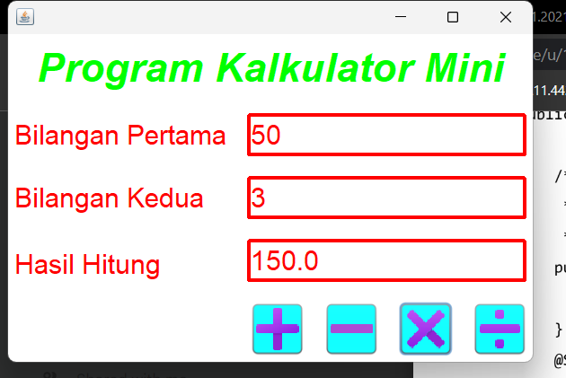

Code Program:

*Form_KalkulatorMIni.java

/*

* Click nbfs://nbhost/SystemFileSystem/Templates/Licenses/license-default.txt to change this license

* Click nbfs://nbhost/SystemFileSystem/Templates/GUIForms/JFrame.java to edit this template

*/

package kalkulator.mini;

/**

*

* @author LENOVO

*/

public class Form_KalkulatorMini extends javax.swing.JFrame {

/**

* Creates new form Form_KalkulatorMini

*/

public Form_KalkulatorMini() {

initComponents();

}

/**

* This method is called from within the constructor to initialize the form.

* WARNING: Do NOT modify this code. The content of this method is always

* regenerated by the Form Editor.

*/

@SuppressWarnings("unchecked")

// <editor-fold defaultstate="collapsed" desc="Generated Code">

private void initComponents() {

panel1 = new javax.swing.JPanel();

jLabel1 = new javax.swing.JLabel();

jLabel2 = new javax.swing.JLabel();

jLabel3 = new javax.swing.JLabel();

input1 = new javax.swing.JTextField();

input2 = new javax.swing.JTextField();

jLabel4 = new javax.swing.JLabel();

hasil = new javax.swing.JTextField();

tambah = new javax.swing.JButton();

kurang = new javax.swing.JButton();

bagi = new javax.swing.JButton();

kali = new javax.swing.JButton();

setDefaultCloseOperation(javax.swing.WindowConstants.EXIT_ON_CLOSE);

panel1.setBackground(new java.awt.Color(255, 255, 255));

jLabel1.setFont(new java.awt.Font("Dialog", 3, 36)); // NOI18N

jLabel1.setForeground(java.awt.Color.green);

jLabel1.setHorizontalAlignment(javax.swing.SwingConstants.CENTER);

jLabel1.setText("Program Kalkulator Mini");

jLabel2.setFont(new java.awt.Font("Dialog", 0, 24)); // NOI18N

jLabel2.setForeground(java.awt.Color.red);

jLabel2.setText("Bilangan Pertama");

jLabel3.setFont(new java.awt.Font("Dialog", 0, 24)); // NOI18N

jLabel3.setForeground(java.awt.Color.red);

jLabel3.setText("Bilangan Kedua");

input1.setBackground(new java.awt.Color(255, 255, 255));

input1.setFont(new java.awt.Font("Dialog", 0, 24)); // NOI18N

input1.setForeground(java.awt.Color.red);

input1.setBorder(new javax.swing.border.LineBorder(java.awt.Color.red, 3, true));

input2.setBackground(new java.awt.Color(255, 255, 255));

input2.setFont(new java.awt.Font("Dialog", 0, 24)); // NOI18N

input2.setForeground(java.awt.Color.red);

input2.setBorder(new javax.swing.border.LineBorder(java.awt.Color.red, 3, true));

jLabel4.setFont(new java.awt.Font("Dialog", 0, 24)); // NOI18N

jLabel4.setForeground(java.awt.Color.red);

jLabel4.setText("Hasil Hitung");

hasil.setBackground(new java.awt.Color(255, 255, 255));

hasil.setFont(new java.awt.Font("Dialog", 0, 24)); // NOI18N

hasil.setForeground(java.awt.Color.red);

hasil.setBorder(new javax.swing.border.LineBorder(java.awt.Color.red, 3, true));

tambah.setBackground(java.awt.Color.cyan);

tambah.setFont(new java.awt.Font("Dialog", 0, 24)); // NOI18N

tambah.setForeground(new java.awt.Color(255, 255, 255));

tambah.setIcon(new javax.swing.ImageIcon(getClass().getResource("/asset/tambah.png"))); // NOI18N

tambah.setBorder(javax.swing.BorderFactory.createCompoundBorder());

tambah.addActionListener(new java.awt.event.ActionListener() {

public void actionPerformed(java.awt.event.ActionEvent evt) {

tambahActionPerformed(evt);

}

});

kurang.setBackground(java.awt.Color.cyan);

kurang.setFont(new java.awt.Font("Dialog", 0, 24)); // NOI18N

kurang.setForeground(new java.awt.Color(255, 255, 255));

kurang.setIcon(new javax.swing.ImageIcon(getClass().getResource("/asset/kurang.png"))); // NOI18N

kurang.setBorder(javax.swing.BorderFactory.createCompoundBorder());

kurang.addActionListener(new java.awt.event.ActionListener() {

public void actionPerformed(java.awt.event.ActionEvent evt) {

kurangActionPerformed(evt);

}

});

bagi.setBackground(java.awt.Color.cyan);

bagi.setFont(new java.awt.Font("Dialog", 0, 24)); // NOI18N

bagi.setForeground(new java.awt.Color(255, 255, 255));

bagi.setIcon(new javax.swing.ImageIcon(getClass().getResource("/asset/bagi.png"))); // NOI18N

bagi.setBorder(javax.swing.BorderFactory.createCompoundBorder());

bagi.addActionListener(new java.awt.event.ActionListener() {

public void actionPerformed(java.awt.event.ActionEvent evt) {

bagiActionPerformed(evt);

}

});

kali.setBackground(java.awt.Color.cyan);

kali.setFont(new java.awt.Font("Dialog", 0, 24)); // NOI18N

kali.setForeground(new java.awt.Color(255, 255, 255));

kali.setIcon(new javax.swing.ImageIcon(getClass().getResource("/asset/kali.png"))); // NOI18N

kali.setBorder(javax.swing.BorderFactory.createCompoundBorder());

kali.addActionListener(new java.awt.event.ActionListener() {

public void actionPerformed(java.awt.event.ActionEvent evt) {

kaliActionPerformed(evt);

}

});

javax.swing.GroupLayout panel1Layout = new javax.swing.GroupLayout(panel1);

panel1.setLayout(panel1Layout);

panel1Layout.setHorizontalGroup(

panel1Layout.createParallelGroup(javax.swing.GroupLayout.Alignment.LEADING)

.addGroup(panel1Layout.createSequentialGroup()

.addContainerGap()

.addGroup(panel1Layout.createParallelGroup(javax.swing.GroupLayout.Alignment.LEADING)

.addComponent(jLabel1, javax.swing.GroupLayout.DEFAULT_SIZE, javax.swing.GroupLayout.DEFAULT_SIZE, Short.MAX_VALUE)

.addGroup(panel1Layout.createSequentialGroup()

.addGap(0, 0, Short.MAX_VALUE)

.addComponent(tambah)

.addGap(18, 18, 18)

.addComponent(kurang)

.addGap(18, 18, 18)

.addComponent(kali)

.addGap(18, 18, 18)

.addComponent(bagi))

.addGroup(panel1Layout.createSequentialGroup()

.addGroup(panel1Layout.createParallelGroup(javax.swing.GroupLayout.Alignment.LEADING)

.addGroup(panel1Layout.createSequentialGroup()

.addComponent(jLabel2)

.addGap(18, 18, 18)

.addComponent(input1, javax.swing.GroupLayout.PREFERRED_SIZE, 249, javax.swing.GroupLayout.PREFERRED_SIZE))

.addGroup(panel1Layout.createSequentialGroup()

.addComponent(jLabel3)

.addGap(38, 38, 38)

.addComponent(input2, javax.swing.GroupLayout.PREFERRED_SIZE, 249, javax.swing.GroupLayout.PREFERRED_SIZE))

.addGroup(panel1Layout.createSequentialGroup()

.addComponent(jLabel4)

.addGap(77, 77, 77)

.addComponent(hasil, javax.swing.GroupLayout.PREFERRED_SIZE, 249, javax.swing.GroupLayout.PREFERRED_SIZE)))

.addGap(0, 0, Short.MAX_VALUE)))

.addContainerGap())

);

panel1Layout.setVerticalGroup(

panel1Layout.createParallelGroup(javax.swing.GroupLayout.Alignment.LEADING)

.addGroup(panel1Layout.createSequentialGroup()

.addContainerGap()

.addComponent(jLabel1)

.addGap(18, 18, 18)

.addGroup(panel1Layout.createParallelGroup(javax.swing.GroupLayout.Alignment.BASELINE)

.addComponent(jLabel2)

.addComponent(input1, javax.swing.GroupLayout.PREFERRED_SIZE, javax.swing.GroupLayout.DEFAULT_SIZE, javax.swing.GroupLayout.PREFERRED_SIZE))

.addGap(18, 18, 18)

.addGroup(panel1Layout.createParallelGroup(javax.swing.GroupLayout.Alignment.BASELINE)

.addComponent(input2, javax.swing.GroupLayout.PREFERRED_SIZE, javax.swing.GroupLayout.DEFAULT_SIZE, javax.swing.GroupLayout.PREFERRED_SIZE)

.addComponent(jLabel3))

.addGap(18, 18, 18)

.addGroup(panel1Layout.createParallelGroup(javax.swing.GroupLayout.Alignment.TRAILING)

.addComponent(hasil, javax.swing.GroupLayout.PREFERRED_SIZE, javax.swing.GroupLayout.DEFAULT_SIZE, javax.swing.GroupLayout.PREFERRED_SIZE)

.addComponent(jLabel4))

.addGap(18, 18, 18)

.addGroup(panel1Layout.createParallelGroup(javax.swing.GroupLayout.Alignment.BASELINE)

.addComponent(tambah)

.addComponent(kurang)

.addComponent(bagi)

.addComponent(kali))

.addContainerGap(javax.swing.GroupLayout.DEFAULT_SIZE, Short.MAX_VALUE))

);

javax.swing.GroupLayout layout = new javax.swing.GroupLayout(getContentPane());

getContentPane().setLayout(layout);

layout.setHorizontalGroup(

layout.createParallelGroup(javax.swing.GroupLayout.Alignment.LEADING)

.addComponent(panel1, javax.swing.GroupLayout.DEFAULT_SIZE, javax.swing.GroupLayout.DEFAULT_SIZE, Short.MAX_VALUE)

);

layout.setVerticalGroup(

layout.createParallelGroup(javax.swing.GroupLayout.Alignment.LEADING)

.addComponent(panel1, javax.swing.GroupLayout.PREFERRED_SIZE, javax.swing.GroupLayout.DEFAULT_SIZE, javax.swing.GroupLayout.PREFERRED_SIZE)

);

pack();

}// </editor-fold>

private void tambahActionPerformed(java.awt.event.ActionEvent evt) {

// TODO add your handling code here:

double hitung1, hitung2, hasil;

String bilangan1 = input1.getText();

String bilangan2 = input2.getText();

hitung1 = Double.parseDouble(this.input1.getText());

hitung2 = Double.parseDouble(this.input2.getText());

hasil = hitung1 + hitung2;

this.hasil.setText("" + hasil);

}

private void kurangActionPerformed(java.awt.event.ActionEvent evt) {

// TODO add your handling code here:

double hitung1, hitung2, hasil;

String bilangan1 = input1.getText();

String bilangan2 = input2.getText();

hitung1 = Double.parseDouble(this.input1.getText());

hitung2 = Double.parseDouble(this.input2.getText());

hasil = hitung1 - hitung2;

this.hasil.setText("" + hasil);

}

private void kaliActionPerformed(java.awt.event.ActionEvent evt) {

// TODO add your handling code here:

double hitung1, hitung2, hasil;

String bilangan1 = input1.getText();

String bilangan2 = input2.getText();

hitung1 = Double.parseDouble(this.input1.getText());

hitung2 = Double.parseDouble(this.input2.getText());

hasil = hitung1 * hitung2;

this.hasil.setText("" + hasil);

}

private void bagiActionPerformed(java.awt.event.ActionEvent evt) {

// TODO add your handling code here:

double hitung1, hitung2, hasil;

String bilangan1 = input1.getText();

String bilangan2 = input2.getText();

hitung1 = Double.parseDouble(this.input1.getText());

hitung2 = Double.parseDouble(this.input2.getText());

hasil = hitung1 / hitung2;

this.hasil.setText("" + hasil);

}

/**

* @param args the command line arguments

*/

public static void main(String args[]) {

/* Set the Nimbus look and feel */

//<editor-fold defaultstate="collapsed" desc=" Look and feel setting code (optional) ">

/* If Nimbus (doubleroduced in Java SE 6) is not available, stay with the default look and feel.

* For details see http://download.oracle.com/javase/tutorial/uiswing/lookandfeel/plaf.html

*/

try {

for (javax.swing.UIManager.LookAndFeelInfo info : javax.swing.UIManager.getInstalledLookAndFeels()) {

if ("Nimbus".equals(info.getName())) {

javax.swing.UIManager.setLookAndFeel(info.getClassName());

break;

}

}

} catch (ClassNotFoundException ex) {

java.util.logging.Logger.getLogger(Form_KalkulatorMini.class.getName()).log(java.util.logging.Level.SEVERE, null, ex);

} catch (InstantiationException ex) {

java.util.logging.Logger.getLogger(Form_KalkulatorMini.class.getName()).log(java.util.logging.Level.SEVERE, null, ex);

} catch (IllegalAccessException ex) {

java.util.logging.Logger.getLogger(Form_KalkulatorMini.class.getName()).log(java.util.logging.Level.SEVERE, null, ex);

} catch (javax.swing.UnsupportedLookAndFeelException ex) {

java.util.logging.Logger.getLogger(Form_KalkulatorMini.class.getName()).log(java.util.logging.Level.SEVERE, null, ex);

}

//</editor-fold>

/* Create and display the form */

java.awt.EventQueue.invokeLater(new Runnable() {

public void run() {

new Form_KalkulatorMini().setVisible(true);

}

});

}

// Variables declaration - do not modify

private javax.swing.JButton bagi;

private javax.swing.JTextField hasil;

private javax.swing.JTextField input1;

private javax.swing.JTextField input2;

private javax.swing.JLabel jLabel1;

private javax.swing.JLabel jLabel2;

private javax.swing.JLabel jLabel3;

private javax.swing.JLabel jLabel4;

private javax.swing.JButton kali;

private javax.swing.JButton kurang;

private javax.swing.JPanel panel1;

private javax.swing.JButton tambah;

// End of variables declaration

}

**Latihan 2**

Hasil Program:

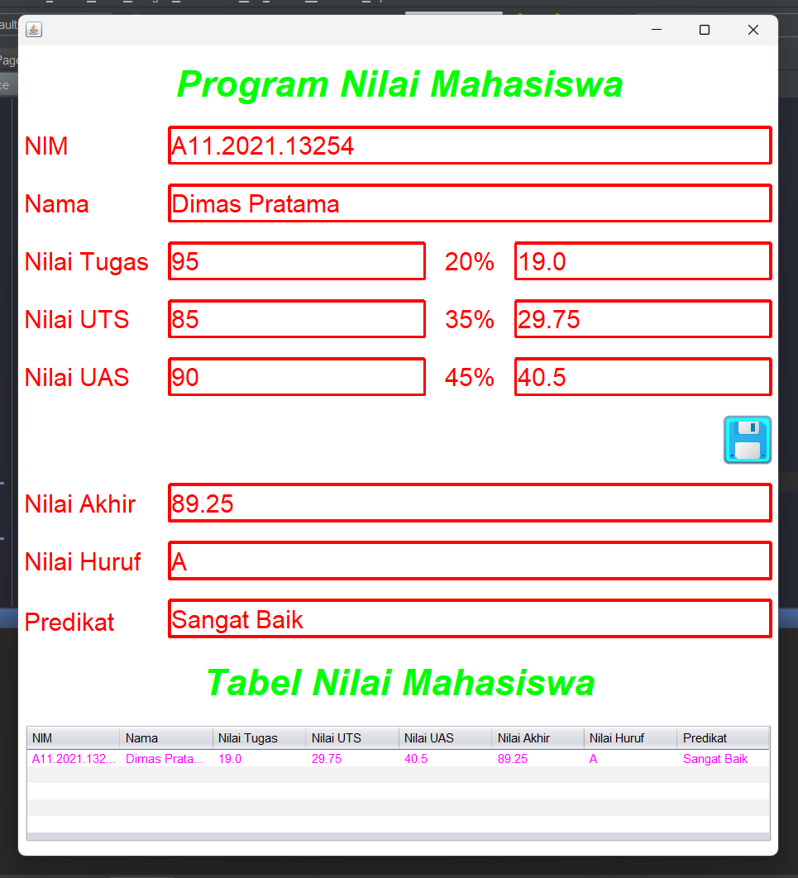

Code Program:

*Form_Nilai.java

/*

* Click nbfs://nbhost/SystemFileSystem/Templates/Licenses/license-default.txt to change this license

* Click nbfs://nbhost/SystemFileSystem/Templates/GUIForms/JFrame.java to edit this template

*/

package nilai;

/**

*

* @author LENOVO

*/

public class Form_Nilai extends javax.swing.JFrame {

/**

* Creates new form Form_Nilai

*/

public Form_Nilai() {

initComponents();

}

/**

* This method is called from within the constructor to initialize the form.

* WARNING: Do NOT modify this code. The content of this method is always

* regenerated by the Form Editor.

*/

@SuppressWarnings("unchecked")

// <editor-fold defaultstate="collapsed" desc="Generated Code">

private void initComponents() {

jPanel1 = new javax.swing.JPanel();

jLabel1 = new javax.swing.JLabel();

jLabel2 = new javax.swing.JLabel();

jLabel3 = new javax.swing.JLabel();

jLabel4 = new javax.swing.JLabel();

jLabel5 = new javax.swing.JLabel();

jLabel6 = new javax.swing.JLabel();

jLabel7 = new javax.swing.JLabel();

jLabel8 = new javax.swing.JLabel();

jLabel9 = new javax.swing.JLabel();

tugas = new javax.swing.JTextField();

jLabel10 = new javax.swing.JLabel();

hasil_tugas = new javax.swing.JTextField();

uts = new javax.swing.JTextField();

jLabel11 = new javax.swing.JLabel();

hasil_uts = new javax.swing.JTextField();

uas = new javax.swing.JTextField();

jLabel12 = new javax.swing.JLabel();

hasil_uas = new javax.swing.JTextField();

nim = new javax.swing.JTextField();

nama = new javax.swing.JTextField();

nilai_akhir = new javax.swing.JTextField();

nilai_huruf = new javax.swing.JTextField();

predikat = new javax.swing.JTextField();

jScrollPane1 = new javax.swing.JScrollPane();

tabel_nilai = new javax.swing.JTable();

save = new javax.swing.JButton();

jLabel13 = new javax.swing.JLabel();

setDefaultCloseOperation(javax.swing.WindowConstants.EXIT_ON_CLOSE);

setBackground(new java.awt.Color(255, 255, 255));

jPanel1.setBackground(new java.awt.Color(255, 255, 255));

jLabel1.setFont(new java.awt.Font("Dialog", 3, 36)); // NOI18N

jLabel1.setForeground(java.awt.Color.green);

jLabel1.setHorizontalAlignment(javax.swing.SwingConstants.CENTER);

jLabel1.setText("Program Nilai Mahasiswa");

jLabel2.setFont(new java.awt.Font("Dialog", 0, 24)); // NOI18N

jLabel2.setForeground(java.awt.Color.red);

jLabel2.setText("NIM");

jLabel3.setFont(new java.awt.Font("Dialog", 0, 24)); // NOI18N

jLabel3.setForeground(java.awt.Color.red);

jLabel3.setText("Nama");

jLabel4.setFont(new java.awt.Font("Dialog", 0, 24)); // NOI18N

jLabel4.setForeground(java.awt.Color.red);

jLabel4.setText("Nilai Tugas");

jLabel5.setFont(new java.awt.Font("Dialog", 0, 24)); // NOI18N

jLabel5.setForeground(java.awt.Color.red);

jLabel5.setText("Nilai UTS");

jLabel6.setFont(new java.awt.Font("Dialog", 0, 24)); // NOI18N

jLabel6.setForeground(java.awt.Color.red);

jLabel6.setText("Nilai UAS");

jLabel7.setFont(new java.awt.Font("Dialog", 0, 24)); // NOI18N

jLabel7.setForeground(java.awt.Color.red);

jLabel7.setText("Nilai Akhir");

jLabel8.setFont(new java.awt.Font("Dialog", 0, 24)); // NOI18N

jLabel8.setForeground(java.awt.Color.red);

jLabel8.setText("Nilai Huruf");

jLabel9.setFont(new java.awt.Font("Dialog", 0, 24)); // NOI18N

jLabel9.setForeground(java.awt.Color.red);

jLabel9.setText("Predikat");

tugas.setFont(new java.awt.Font("Dialog", 0, 24)); // NOI18N

tugas.setForeground(java.awt.Color.red);

tugas.setBorder(new javax.swing.border.LineBorder(java.awt.Color.red, 3, true));

jLabel10.setFont(new java.awt.Font("Dialog", 0, 24)); // NOI18N

jLabel10.setForeground(java.awt.Color.red);

jLabel10.setText("20%");

hasil_tugas.setFont(new java.awt.Font("Dialog", 0, 24)); // NOI18N

hasil_tugas.setForeground(java.awt.Color.red);

hasil_tugas.setBorder(new javax.swing.border.LineBorder(java.awt.Color.red, 3, true));

uts.setFont(new java.awt.Font("Dialog", 0, 24)); // NOI18N

uts.setForeground(java.awt.Color.red);

uts.setBorder(new javax.swing.border.LineBorder(java.awt.Color.red, 3, true));

jLabel11.setFont(new java.awt.Font("Dialog", 0, 24)); // NOI18N

jLabel11.setForeground(java.awt.Color.red);

jLabel11.setText("35%");

hasil_uts.setFont(new java.awt.Font("Dialog", 0, 24)); // NOI18N

hasil_uts.setForeground(java.awt.Color.red);

hasil_uts.setBorder(new javax.swing.border.LineBorder(java.awt.Color.red, 3, true));

uas.setFont(new java.awt.Font("Dialog", 0, 24)); // NOI18N

uas.setForeground(java.awt.Color.red);

uas.setBorder(new javax.swing.border.LineBorder(java.awt.Color.red, 3, true));

jLabel12.setFont(new java.awt.Font("Dialog", 0, 24)); // NOI18N

jLabel12.setForeground(java.awt.Color.red);

jLabel12.setText("45%");

hasil_uas.setFont(new java.awt.Font("Dialog", 0, 24)); // NOI18N

hasil_uas.setForeground(java.awt.Color.red);

hasil_uas.setBorder(new javax.swing.border.LineBorder(java.awt.Color.red, 3, true));

nim.setFont(new java.awt.Font("Dialog", 0, 24)); // NOI18N

nim.setForeground(java.awt.Color.red);

nim.setBorder(new javax.swing.border.LineBorder(java.awt.Color.red, 3, true));

nama.setFont(new java.awt.Font("Dialog", 0, 24)); // NOI18N

nama.setForeground(java.awt.Color.red);

nama.setBorder(new javax.swing.border.LineBorder(java.awt.Color.red, 3, true));

nilai_akhir.setFont(new java.awt.Font("Dialog", 0, 24)); // NOI18N

nilai_akhir.setForeground(java.awt.Color.red);

nilai_akhir.setBorder(new javax.swing.border.LineBorder(java.awt.Color.red, 3, true));

nilai_akhir.addActionListener(new java.awt.event.ActionListener() {

public void actionPerformed(java.awt.event.ActionEvent evt) {

nilai_akhirActionPerformed(evt);

}

});

nilai_huruf.setFont(new java.awt.Font("Dialog", 0, 24)); // NOI18N

nilai_huruf.setForeground(java.awt.Color.red);

nilai_huruf.setBorder(new javax.swing.border.LineBorder(java.awt.Color.red, 3, true));

predikat.setFont(new java.awt.Font("Dialog", 0, 24)); // NOI18N

predikat.setForeground(java.awt.Color.red);

predikat.setBorder(new javax.swing.border.LineBorder(java.awt.Color.red, 3, true));

tabel_nilai.setForeground(java.awt.Color.magenta);

tabel_nilai.setModel(new javax.swing.table.DefaultTableModel(

new Object [][] {

{null, null, null, null, null, null, null, null},

{null, null, null, null, null, null, null, null},

{null, null, null, null, null, null, null, null},

{null, null, null, null, null, null, null, null},

{null, null, null, null, null, null, null, null}

},

new String [] {

"NIM", "Nama", "Nilai Tugas", "Nilai UTS", "Nilai UAS", "Nilai Akhir", "Nilai Huruf", "Predikat"

}

));

jScrollPane1.setViewportView(tabel_nilai);

save.setBackground(java.awt.Color.cyan);

save.setIcon(new javax.swing.ImageIcon(getClass().getResource("/asset/save.png"))); // NOI18N

save.setBorder(javax.swing.BorderFactory.createCompoundBorder());

save.addActionListener(new java.awt.event.ActionListener() {

public void actionPerformed(java.awt.event.ActionEvent evt) {

saveActionPerformed(evt);

}

});

jLabel13.setFont(new java.awt.Font("Dialog", 3, 36)); // NOI18N

jLabel13.setForeground(java.awt.Color.green);

jLabel13.setHorizontalAlignment(javax.swing.SwingConstants.CENTER);

jLabel13.setText("Tabel Nilai Mahasiswa");

javax.swing.GroupLayout jPanel1Layout = new javax.swing.GroupLayout(jPanel1);

jPanel1.setLayout(jPanel1Layout);

jPanel1Layout.setHorizontalGroup(

jPanel1Layout.createParallelGroup(javax.swing.GroupLayout.Alignment.LEADING)

.addGap(0, 736, Short.MAX_VALUE)

.addGroup(jPanel1Layout.createParallelGroup(javax.swing.GroupLayout.Alignment.LEADING)

.addGroup(jPanel1Layout.createSequentialGroup()

.addContainerGap()

.addGroup(jPanel1Layout.createParallelGroup(javax.swing.GroupLayout.Alignment.LEADING)

.addComponent(jLabel1, javax.swing.GroupLayout.DEFAULT_SIZE, javax.swing.GroupLayout.DEFAULT_SIZE, Short.MAX_VALUE)

.addComponent(jScrollPane1)

.addComponent(jLabel13, javax.swing.GroupLayout.DEFAULT_SIZE, javax.swing.GroupLayout.DEFAULT_SIZE, Short.MAX_VALUE)

.addGroup(javax.swing.GroupLayout.Alignment.TRAILING, jPanel1Layout.createSequentialGroup()

.addGap(0, 0, Short.MAX_VALUE)

.addComponent(save))

.addGroup(jPanel1Layout.createSequentialGroup()

.addGroup(jPanel1Layout.createParallelGroup(javax.swing.GroupLayout.Alignment.LEADING)

.addComponent(jLabel4)

.addComponent(jLabel5)

.addComponent(jLabel6)

.addComponent(jLabel3)

.addComponent(jLabel2)

.addComponent(jLabel7)

.addComponent(jLabel8)

.addComponent(jLabel9))

.addGap(18, 18, 18)

.addGroup(jPanel1Layout.createParallelGroup(javax.swing.GroupLayout.Alignment.LEADING)

.addComponent(predikat)

.addComponent(nilai_huruf)

.addComponent(nilai_akhir)

.addGroup(jPanel1Layout.createSequentialGroup()

.addGroup(jPanel1Layout.createParallelGroup(javax.swing.GroupLayout.Alignment.TRAILING, false)

.addComponent(nim, javax.swing.GroupLayout.Alignment.LEADING)

.addGroup(javax.swing.GroupLayout.Alignment.LEADING, jPanel1Layout.createSequentialGroup()

.addComponent(uas, javax.swing.GroupLayout.PREFERRED_SIZE, 250, javax.swing.GroupLayout.PREFERRED_SIZE)

.addGap(18, 18, 18)

.addComponent(jLabel12)

.addGap(18, 18, 18)

.addComponent(hasil_uas, javax.swing.GroupLayout.PREFERRED_SIZE, 250, javax.swing.GroupLayout.PREFERRED_SIZE))

.addGroup(javax.swing.GroupLayout.Alignment.LEADING, jPanel1Layout.createSequentialGroup()

.addComponent(uts, javax.swing.GroupLayout.PREFERRED_SIZE, 250, javax.swing.GroupLayout.PREFERRED_SIZE)

.addGap(18, 18, 18)

.addComponent(jLabel11)

.addGap(18, 18, 18)

.addComponent(hasil_uts, javax.swing.GroupLayout.PREFERRED_SIZE, 250, javax.swing.GroupLayout.PREFERRED_SIZE))

.addGroup(javax.swing.GroupLayout.Alignment.LEADING, jPanel1Layout.createSequentialGroup()

.addComponent(tugas, javax.swing.GroupLayout.PREFERRED_SIZE, 250, javax.swing.GroupLayout.PREFERRED_SIZE)

.addGap(18, 18, 18)

.addComponent(jLabel10)

.addGap(18, 18, 18)

.addComponent(hasil_tugas, javax.swing.GroupLayout.PREFERRED_SIZE, 250, javax.swing.GroupLayout.PREFERRED_SIZE))

.addComponent(nama, javax.swing.GroupLayout.Alignment.LEADING, javax.swing.GroupLayout.PREFERRED_SIZE, 585, javax.swing.GroupLayout.PREFERRED_SIZE))

.addGap(0, 0, Short.MAX_VALUE)))))

.addContainerGap()))

);

jPanel1Layout.setVerticalGroup(

jPanel1Layout.createParallelGroup(javax.swing.GroupLayout.Alignment.LEADING)

.addGap(0, 785, Short.MAX_VALUE)

.addGroup(jPanel1Layout.createParallelGroup(javax.swing.GroupLayout.Alignment.LEADING)

.addGroup(jPanel1Layout.createSequentialGroup()

.addGap(13, 13, 13)

.addComponent(jLabel1)

.addGap(18, 18, 18)

.addGroup(jPanel1Layout.createParallelGroup(javax.swing.GroupLayout.Alignment.BASELINE)

.addComponent(jLabel2)

.addComponent(nim, javax.swing.GroupLayout.PREFERRED_SIZE, javax.swing.GroupLayout.DEFAULT_SIZE, javax.swing.GroupLayout.PREFERRED_SIZE))

.addGap(18, 18, 18)

.addGroup(jPanel1Layout.createParallelGroup(javax.swing.GroupLayout.Alignment.BASELINE)

.addComponent(jLabel3)

.addComponent(nama, javax.swing.GroupLayout.PREFERRED_SIZE, javax.swing.GroupLayout.DEFAULT_SIZE, javax.swing.GroupLayout.PREFERRED_SIZE))

.addGap(18, 18, 18)

.addGroup(jPanel1Layout.createParallelGroup(javax.swing.GroupLayout.Alignment.BASELINE)

.addComponent(jLabel4)

.addComponent(tugas, javax.swing.GroupLayout.PREFERRED_SIZE, javax.swing.GroupLayout.DEFAULT_SIZE, javax.swing.GroupLayout.PREFERRED_SIZE)

.addComponent(jLabel10)

.addComponent(hasil_tugas, javax.swing.GroupLayout.PREFERRED_SIZE, javax.swing.GroupLayout.DEFAULT_SIZE, javax.swing.GroupLayout.PREFERRED_SIZE))

.addGap(18, 18, 18)

.addGroup(jPanel1Layout.createParallelGroup(javax.swing.GroupLayout.Alignment.BASELINE)

.addComponent(jLabel5)

.addComponent(uts, javax.swing.GroupLayout.PREFERRED_SIZE, javax.swing.GroupLayout.DEFAULT_SIZE, javax.swing.GroupLayout.PREFERRED_SIZE)

.addComponent(jLabel11)

.addComponent(hasil_uts, javax.swing.GroupLayout.PREFERRED_SIZE, javax.swing.GroupLayout.DEFAULT_SIZE, javax.swing.GroupLayout.PREFERRED_SIZE))

.addGap(18, 18, 18)

.addGroup(jPanel1Layout.createParallelGroup(javax.swing.GroupLayout.Alignment.BASELINE)

.addComponent(jLabel6)

.addComponent(uas, javax.swing.GroupLayout.PREFERRED_SIZE, javax.swing.GroupLayout.DEFAULT_SIZE, javax.swing.GroupLayout.PREFERRED_SIZE)

.addComponent(jLabel12)

.addComponent(hasil_uas, javax.swing.GroupLayout.PREFERRED_SIZE, javax.swing.GroupLayout.DEFAULT_SIZE, javax.swing.GroupLayout.PREFERRED_SIZE))

.addGap(18, 18, 18)

.addComponent(save)

.addGap(18, 18, 18)

.addGroup(jPanel1Layout.createParallelGroup(javax.swing.GroupLayout.Alignment.TRAILING)

.addGroup(jPanel1Layout.createSequentialGroup()

.addGroup(jPanel1Layout.createParallelGroup(javax.swing.GroupLayout.Alignment.BASELINE)

.addComponent(nilai_akhir, javax.swing.GroupLayout.PREFERRED_SIZE, javax.swing.GroupLayout.DEFAULT_SIZE, javax.swing.GroupLayout.PREFERRED_SIZE)

.addComponent(jLabel7))

.addGap(18, 18, 18)

.addGroup(jPanel1Layout.createParallelGroup(javax.swing.GroupLayout.Alignment.BASELINE)

.addComponent(nilai_huruf, javax.swing.GroupLayout.PREFERRED_SIZE, javax.swing.GroupLayout.DEFAULT_SIZE, javax.swing.GroupLayout.PREFERRED_SIZE)

.addComponent(jLabel8))

.addGap(18, 18, 18)

.addComponent(predikat, javax.swing.GroupLayout.PREFERRED_SIZE, javax.swing.GroupLayout.DEFAULT_SIZE, javax.swing.GroupLayout.PREFERRED_SIZE))

.addComponent(jLabel9))

.addGap(18, 18, 18)

.addComponent(jLabel13)

.addGap(18, 18, 18)

.addComponent(jScrollPane1, javax.swing.GroupLayout.PREFERRED_SIZE, 115, javax.swing.GroupLayout.PREFERRED_SIZE)

.addContainerGap(13, Short.MAX_VALUE)))

);

javax.swing.GroupLayout layout = new javax.swing.GroupLayout(getContentPane());

getContentPane().setLayout(layout);

layout.setHorizontalGroup(

layout.createParallelGroup(javax.swing.GroupLayout.Alignment.LEADING)

.addComponent(jPanel1, javax.swing.GroupLayout.Alignment.TRAILING, javax.swing.GroupLayout.DEFAULT_SIZE, javax.swing.GroupLayout.DEFAULT_SIZE, Short.MAX_VALUE)

);

layout.setVerticalGroup(

layout.createParallelGroup(javax.swing.GroupLayout.Alignment.LEADING)

.addComponent(jPanel1, javax.swing.GroupLayout.DEFAULT_SIZE, javax.swing.GroupLayout.DEFAULT_SIZE, Short.MAX_VALUE)

);

pack();

}// </editor-fold>

private void saveActionPerformed(java.awt.event.ActionEvent evt) {

// TODO add your handling code here:

String textnim = nim.getText();

String textnama = nama.getText();

String texttugas = tugas.getText();

String textuts = uts.getText();

String textuas = uas.getText();

float tugas = Integer.parseInt(texttugas);

float uts = Integer.parseInt(textuts);

float uas = Integer.parseInt(textuas);

float ntugas, nuts, nuas, nakhir;

ntugas = tugas * 20 / 100;

nuts = uts * 35 / 100;

nuas = uas * 45 / 100;

nakhir = ntugas + nuts + nuas;

hasil_tugas.setText("" + ntugas);

hasil_uts.setText("" + nuts);

hasil_uas.setText("" + nuas);

nilai_akhir.setText("" + nakhir);

// nilai_huruf

if(nakhir>=85){

nilai_huruf.setText("A");

predikat.setText("Sangat Baik");

}else if(nakhir<85 && nakhir>=75){

nilai_huruf.setText("B");

predikat.setText("Cukup Baik");

}else if(nakhir<75 && nakhir>=65){

nilai_huruf.setText("C");

predikat.setText("Cukup");

}else if(nakhir<65 && nakhir>=50){

nilai_huruf.setText("D");

predikat.setText("Cukup Jelek");

}else{

nilai_huruf.setText("E");

predikat.setText("Sangat Jelek");

}

// table

tabel_nilai.setValueAt(textnim, 0, 0);

tabel_nilai.setValueAt(textnama, 0, 1);

tabel_nilai.setValueAt(hasil_tugas.getText(), 0, 2);

tabel_nilai.setValueAt(hasil_uts.getText(), 0, 3);

tabel_nilai.setValueAt(hasil_uas.getText(), 0, 4);

tabel_nilai.setValueAt(nilai_akhir.getText(), 0, 5);

tabel_nilai.setValueAt(nilai_huruf.getText(), 0, 6);

tabel_nilai.setValueAt(predikat.getText(), 0, 7);

}

private void nilai_akhirActionPerformed(java.awt.event.ActionEvent evt) {

// TODO add your handling code here:

}

/**

* @param args the command line arguments

*/

public static void main(String args[]) {

/* Set the Nimbus look and feel */

//<editor-fold defaultstate="collapsed" desc=" Look and feel setting code (optional) ">

/* If Nimbus (introduced in Java SE 6) is not available, stay with the default look and feel.

* For details see http://download.oracle.com/javase/tutorial/uiswing/lookandfeel/plaf.html

*/

try {

for (javax.swing.UIManager.LookAndFeelInfo info : javax.swing.UIManager.getInstalledLookAndFeels()) {

if ("Nimbus".equals(info.getName())) {

javax.swing.UIManager.setLookAndFeel(info.getClassName());

break;

}

}

} catch (ClassNotFoundException ex) {

java.util.logging.Logger.getLogger(Form_Nilai.class.getName()).log(java.util.logging.Level.SEVERE, null, ex);

} catch (InstantiationException ex) {

java.util.logging.Logger.getLogger(Form_Nilai.class.getName()).log(java.util.logging.Level.SEVERE, null, ex);

} catch (IllegalAccessException ex) {

java.util.logging.Logger.getLogger(Form_Nilai.class.getName()).log(java.util.logging.Level.SEVERE, null, ex);

} catch (javax.swing.UnsupportedLookAndFeelException ex) {

java.util.logging.Logger.getLogger(Form_Nilai.class.getName()).log(java.util.logging.Level.SEVERE, null, ex);

}

//</editor-fold>

/* Create and display the form */

java.awt.EventQueue.invokeLater(new Runnable() {

public void run() {

new Form_Nilai().setVisible(true);

}

});

}

// Variables declaration - do not modify

private javax.swing.JTextField hasil_tugas;

private javax.swing.JTextField hasil_uas;

private javax.swing.JTextField hasil_uts;

private javax.swing.JLabel jLabel1;

private javax.swing.JLabel jLabel10;

private javax.swing.JLabel jLabel11;

private javax.swing.JLabel jLabel12;

private javax.swing.JLabel jLabel13;

private javax.swing.JLabel jLabel2;

private javax.swing.JLabel jLabel3;

private javax.swing.JLabel jLabel4;

private javax.swing.JLabel jLabel5;

private javax.swing.JLabel jLabel6;

private javax.swing.JLabel jLabel7;

private javax.swing.JLabel jLabel8;

private javax.swing.JLabel jLabel9;

private javax.swing.JPanel jPanel1;

private javax.swing.JScrollPane jScrollPane1;

private javax.swing.JTextField nama;

private javax.swing.JTextField nilai_akhir;

private javax.swing.JTextField nilai_huruf;

private javax.swing.JTextField nim;

private javax.swing.JTextField predikat;

private javax.swing.JButton save;

private javax.swing.JTable tabel_nilai;

private javax.swing.JTextField tugas;

private javax.swing.JTextField uas;

private javax.swing.JTextField uts;

// End of variables declaration

}